––––

The Royal Association of Justices of Western Australia (Inc), commonly referred to as RAJWA is the peak body representing Justices of the Peace (JPs) throughout Western Australia. We work closely with stakeholders in the justice and community sector by providing support, offering opportunities for professional development and social networking to enhance the skills of JPs as they serve their community.
RAJWA membership provides invaluable opportunities for members to improve skills, share knowledge and participate in social and professional events, including support from our branches, our mentorship program, social events, Facebook and website.
Peer support Our central office staff are on hand to support you on 94252824 or 0480 279 652.
Signing centres We manage rosters for several centres such as at courthouses where you can help even more of the public. Existing roster volunteers are always happy to assist new JPs.
Merchandise RAJWA has a range of branded merchandise that includes personalised products. Your membership gives you access to the dedicated Member area on our website, and you can order directly from it.
Branches We can refer you to one of our branches for opportunities to interact with other JPs.
Statistics Our website Member area includes an automated statistics form for you to upload your statistics into every six months. These are forwarded automatically to the Registrar.
Membership certificate All new members receive an ornate A4 size framable Certificate of Membership with our official seal on it to hang beside your Commission.
Rules The Associations Incorporation Act (2015) requires you to see our Rules when you become a Member. These can be downloaded from our website or emailed to you on request.
Merchandise for new members: white plastic name badge with our logo and with your details. This has proved to be very useful in allowing public and police to greet and identify us. The badge is available with a pin closure or magnetic catch. RAJWA lapel badge, metal with stud closure. Photo ID card with the RAJWA logo, with removable plastic cover. We also sell lanyards with the RAJWA logo to match.
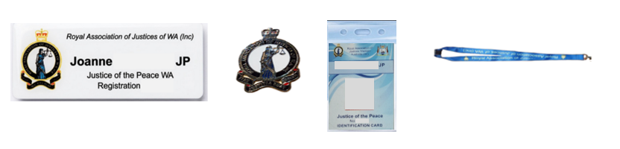
MEMBERSHIP APPLICATION
Title: Dr/Ms/Mr/Other (please specify) _____________ JP number:___________________
I, _____________________________________________________________________________ of
(address) ________________________________________________________________________ ____________________________________________________ P/code ______________________
apply to become a Member of RAJWA and agree to comply with RAJWA’s Rules.
Date of appointment as a JP of WA: / / 20 Date of birth: / /
Contact number/s: ______________________________ /______________________________
Please complete this form, scan and send to rajwa@rajwa.org.au or post to the above address.
Annual subscription | $60 | $
Membership lapel badge | $10 | $
Photo identification card with cover (to attach lanyard) | $14 | $
RAJWA lanyard | $10 | $
White plastic badge with magnetic fastener or | $18 | $
White plastic badge with pin fastener | $18 | $
Total remittance once application accepted: | - | $

Signature: Date:
Email:
Process: Once we receive this form, we acknowledge your email and present your application for Council approval. If accepted, we will then issue an invoice which has payment instructions included. Do not attach payment to this application.
We look forward to you joining our association.
Kind regards,
Registrar & Council

